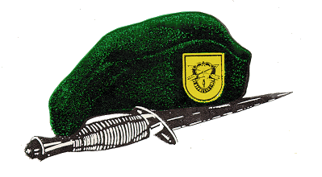
Ballad of the Green Beret

Fighting soldiers from the sky, Fearless men who jump and die. Men who mean just what they say, the brave men of the Green Beret.

Silver wings upon their chest; these are men, America's best. One hundred men will test today, but only three win the Green Beret.

Trained to live off nature's land, Trained in combat, hand to hand. Men who fight by night and day, Courage peak from the Green Berets.

Silver wings upon their chest; these are men, America's best. One hundred men will test today, but only three win the Green Beret.

Back at home a young wife waits, Her Green Beret
has met his fate. He has died for those oppressed, Leaving her his last request.

Put silver wings on my son's chest; Make him one of America's best. He'll be a man they'll test one day, Have him win the Green Beret.

