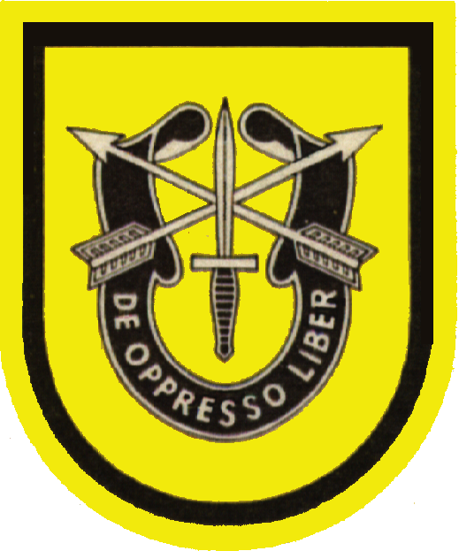
Beret Flash and Regimental Crest
The First Special Forces Group Flash, worn on our Green Berets, is “Asian Gold’, depicting our regional orientation, with a black
band that was
added upon
the death of
President
John F. Kennedy,
as a measure of
respect to a
president that
had been a strong
supporter of the
Special Forces.
The Special Forces
Crest displays the commando dagger, crossed arrows and a scroll bearing the revered Special Forces motto: “De Oppresso Liber”, which means “To Free the Oppressed”.

