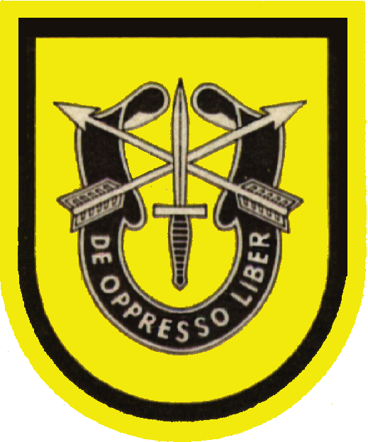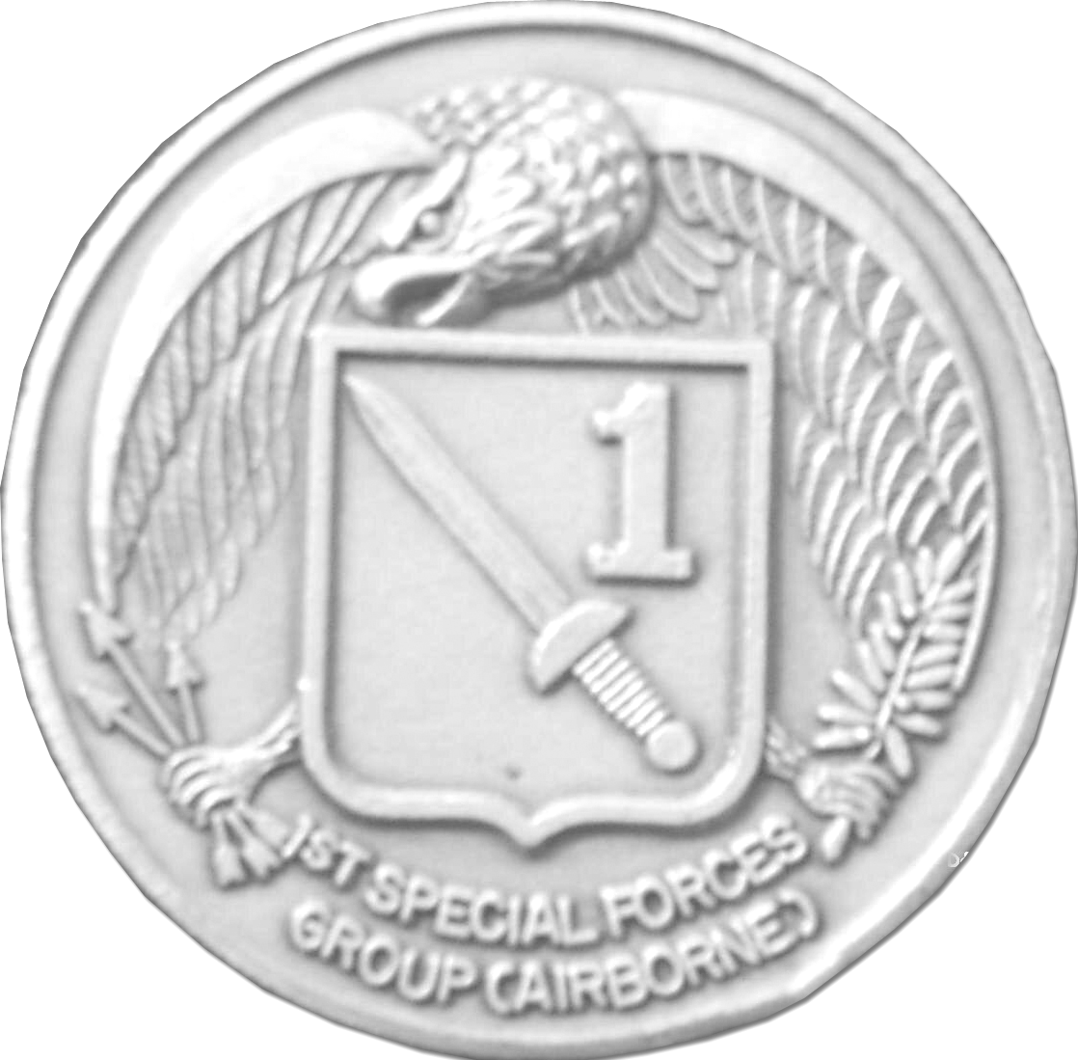
The Heraldry
Of the
1st Special Forces Group
(Airborne)
Coin
The first Special Forces Group (Airborne) derives its Heraldry directly form the unit colors, crest and shield of the First Special Service Force – Its parent combat regimental unit.
The bold, powerful “war” eagle symbolizes several aspects and relationships of the First Special Forces Group (Airborne). First and foremost, it represents the National Eagle that is carried on its unit colors.
It also bears resemblance to the Pacific Area Command (PACOM) eagle – The tactical area of responsibility toward which the Group is oriented. Lastly, the eagle characterizes the Group’s airborne capability to strike swiftly and silently from the air.
Clutched within the eagle’s right claw are three arrows, each one representing an organic line battalion. The center protruding arrow, signifies the forward deployed battalion; all arrows are pointing to the left in cardinal direction to the west. The arrows in the right claw highlight the importance of the First Special Forces Group (Airborne)’s wartime requirements and the need to be instantly ready to execute those missions. The eagle faces to the west with its sharp eyes in constant vigilance of a threat to its homeland.
The eagle also carries in its left claw, the olive branch of peace representing the foreign security assistance missions it is tasked to conduct in peacetime. The seventeen leaves stand for the seventeen year contribution to the preservation of freedom, which the Group made from 1957 to 1974 before it was deactivated. The four olives signify the separate organic companies of Headquarter & Headquarters Company, Signal, Military Intelligence, and Service support reminding us of their vital role in sustaining the Force.
Positioned in the center, the Shield – Again taken from its units colors – contains the distinctive fighting dagger representing the unconventional missions of the Special Forces. In the upper left corner of the shield the two crossed arrows reflect the straight and true qualities of the Special Forces Soldier and the basic weapon of earliest American Guerilla – The American Indians.
Finally, the embossed “1” in the lower right of the shield identifies the First Special Forces Group (Airborne).

