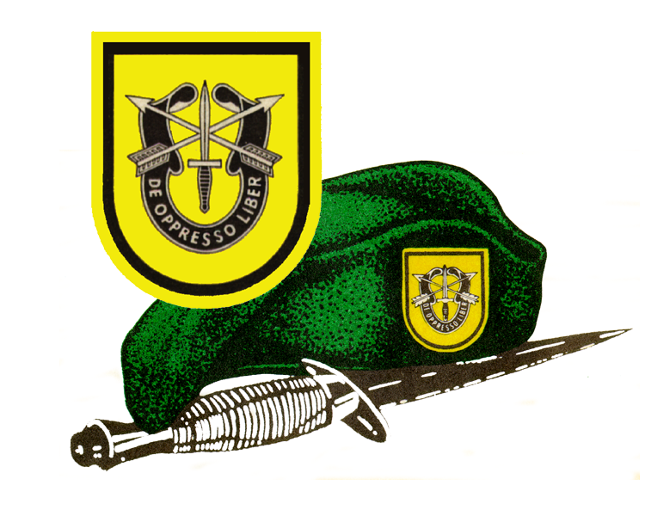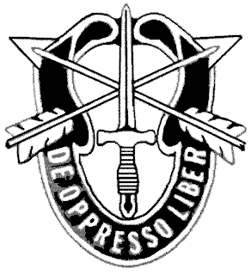
Special Forces Creed
“De Oppresso Liber”
I am an American Special Forces soldier! A professional!
I will do all that my nation requires of me. I am a volunteer.
Knowing well the hazards of my profession.
I serve with the memory of those who have gone before me: Roger’s Rangers, Francis Marion, Mosby’s Rangers, The First Special Service Force, the Jedburghs, Detachment 101, and the Special Forces soldiers of the Vietnam War, who won 17 Medals of Honor and 90 Distinguished Service Crosses. I pledge to uphold the honor and Integrity of all these, in that I am, in all that I do.
I am a profession soldier. I will teach and fight wherever my nation requires, to liberate the oppressed. I will strive always to excel in every art and artifice of war.
I know that I will be called upon to perform tasks in isolation, far from familiar faces and voices. With the help and guidance of my God, I will conquer my fears and succeed.
I will not fail those with whom I serve. I will not bring shame upon myself of the Forces.
I will maintain myself, my arms and my equipment in an immaculate State as befits a Special Forces soldier. My goal is to succeed in any mission and live to succeed again.
I am a member of my nation’s chosen soldiery. God grant that I may not be found wanting, that I will not fail this sacred trust.

