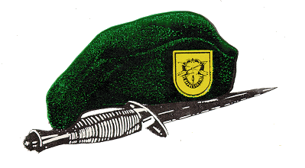
SOF Truths
Humans are more important than Hardware.

Quality is better than Quantity.

Special Operations Forces cannot be mass produced.

Competent Special Operations Forces cannot be created after emergencies occur.

